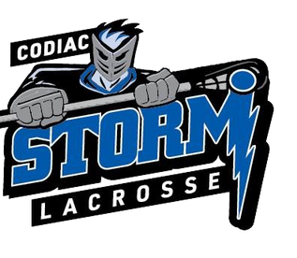

5th Annual Codiac Cup When: June 13, 14 & 15, 2025 Where: Byron Dobson Arenas, Riverview, NB Register Deadline: Midnight, May 19th, 2025

Codiac Storm Lacrosse invites you to our 5th Codiac Cup presented by MacDonald Buick GMC Ltd.

* A submitted application/ payment does NOT guarantee placement
* Co-ed divisions
* Guaranteed 3 games
* Championship round includes semi-final cross-over and final
* U11, U13 & U15 Registration fee: $400

o First place banner U11, U13, U15 & U17

* Teams must register by age/ skill level divisions (teams may not “play down”)
* Registration U9 combined teams $50

20-minute, cross-floor, Coaches-as-Officials game, non-scored - all June 14th Teams will be contacted re # of games and payment, pending entries.

Do NOT send payment with registration. All athletes receive Awards.

2025 Codiac Cup tournament rules and regulations (U11 and up)

This is a club tournament.

One hour per game is scheduled. That hour includes

* 3 minute warm up,
* 1 minute intermissions
* All U11, U13, U15 and U17 games are 12-12-12 minute periods, stop time
* All U9 games are 20 minutes, run time

CLA rules regarding penalties

Standings determined as follows (11U and older)

* most points (2 for win, 1 for tie, 0 loss)
* most wins
* fewest penalty minutes
* quickest goal in first game of the tournament
* coin flip

The rules regarding standings prevent teams from running up the score. Goals for and against are not determining factors.

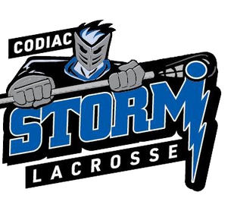

Play-off games

* + Add 5 minutes of overtime as needed (use the full 5 minutes)
  + Shoot out if still tied: 3 players selected, total goals.
  + If still tied, sudden death shoot out, 1 player at a time. All players must be used before players can re-attempt. If 1 team has fewer players, once that team exhausts all players and must re-use a player, the opposing team may also commence re-using their players, even if all their players have not yet competed.

For information contact:

Eric Murray, email cod [iaclacrosse@gmail.com or 506-863-8802](mailto:iaclacrosse@gmail.comor506-863-8802)

Please forward the registration form and fee by MAY 13, midnight, to:

Email: [codiaclacrosse@gmail.com](mailto:codiaclacrosse@gmail.com) with Subject: Codiac Cup 2025 Registration Website: codiaclacrosse.com



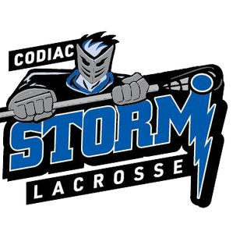

Codiac Storm Lacrosse Codiac Cup 2025 application

Please ensure registration fee is enclosed to secure spot. All cheques payable to “Codiac Storm Lacrosse” (or E-Transfer to Codiac Storm Lacrosse Treasurer Anne Othen at [codiaclacrosse@gmail.com](mailto:codiaclacrosse@gmail.com) (indicating team name and division). No team (11U and above) will be scheduled without advance payment.

U9 teams: do NOT send payment with registration. Teams will be contacted re number of games and final payment, pending entries.

Codiac Cup 2025 Lacrosse Association Team Division (U11, U13, U15 or U17)

Team Name

Home Away

Jersey Colors

Manager Name

Phone Number(s) Email

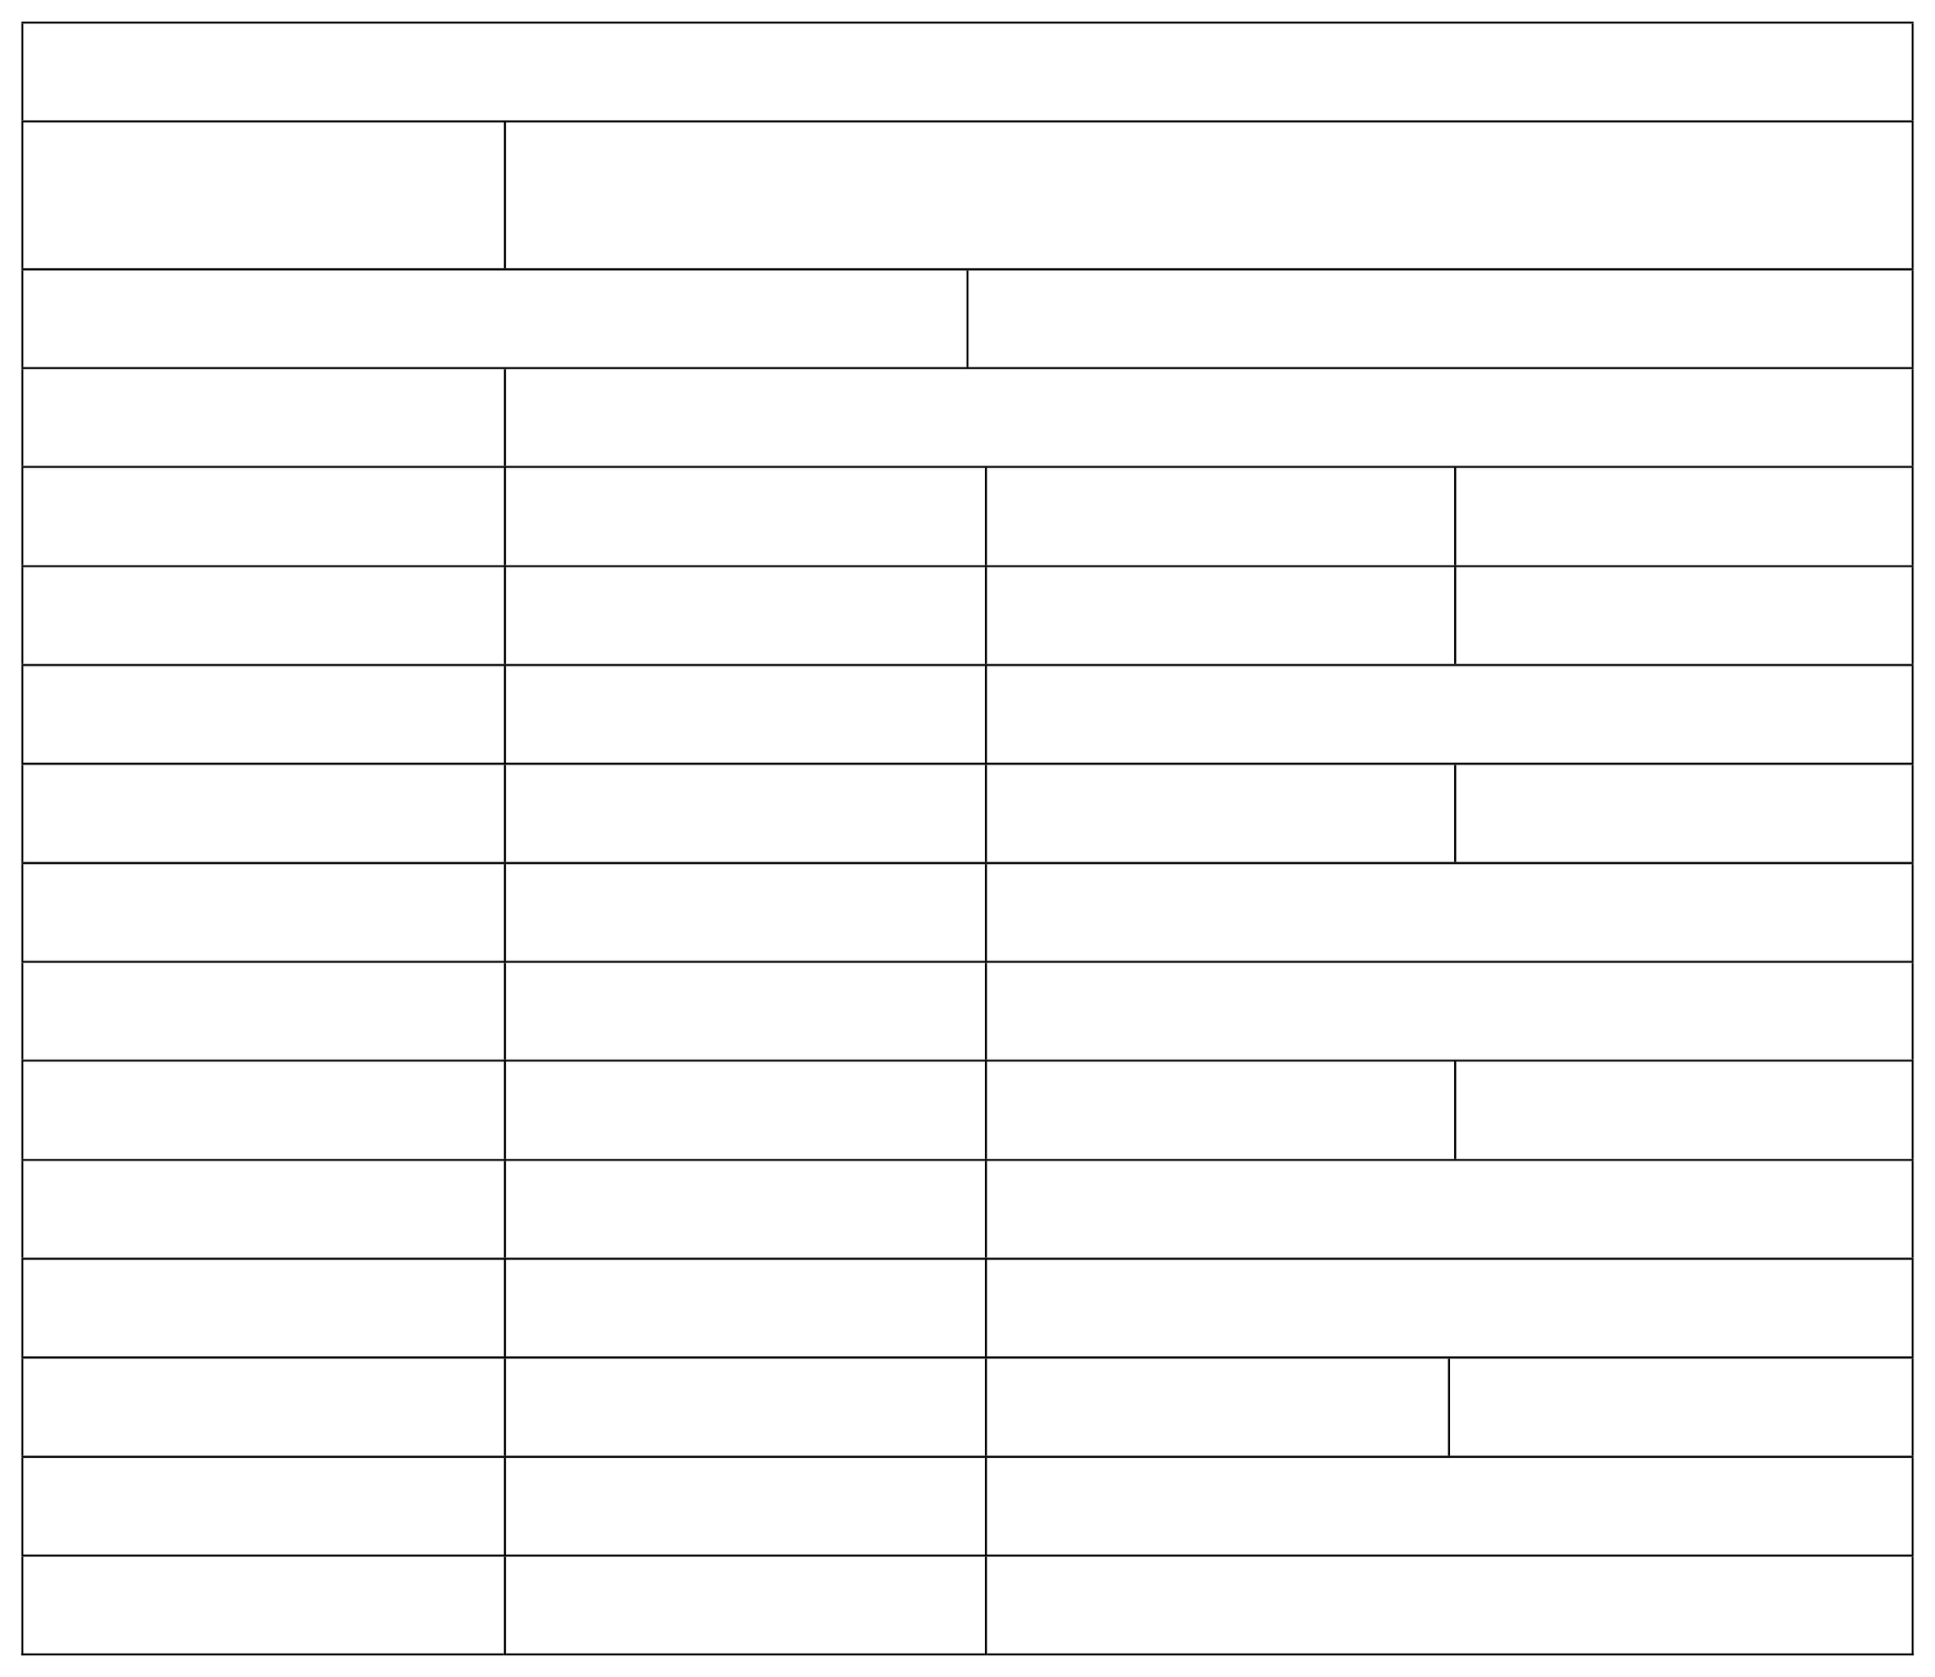Head Coach

Assistant Coach

Name

Phone Number(s) Email

Name

Phone Number(s) Email

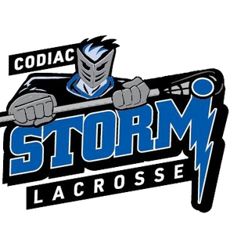

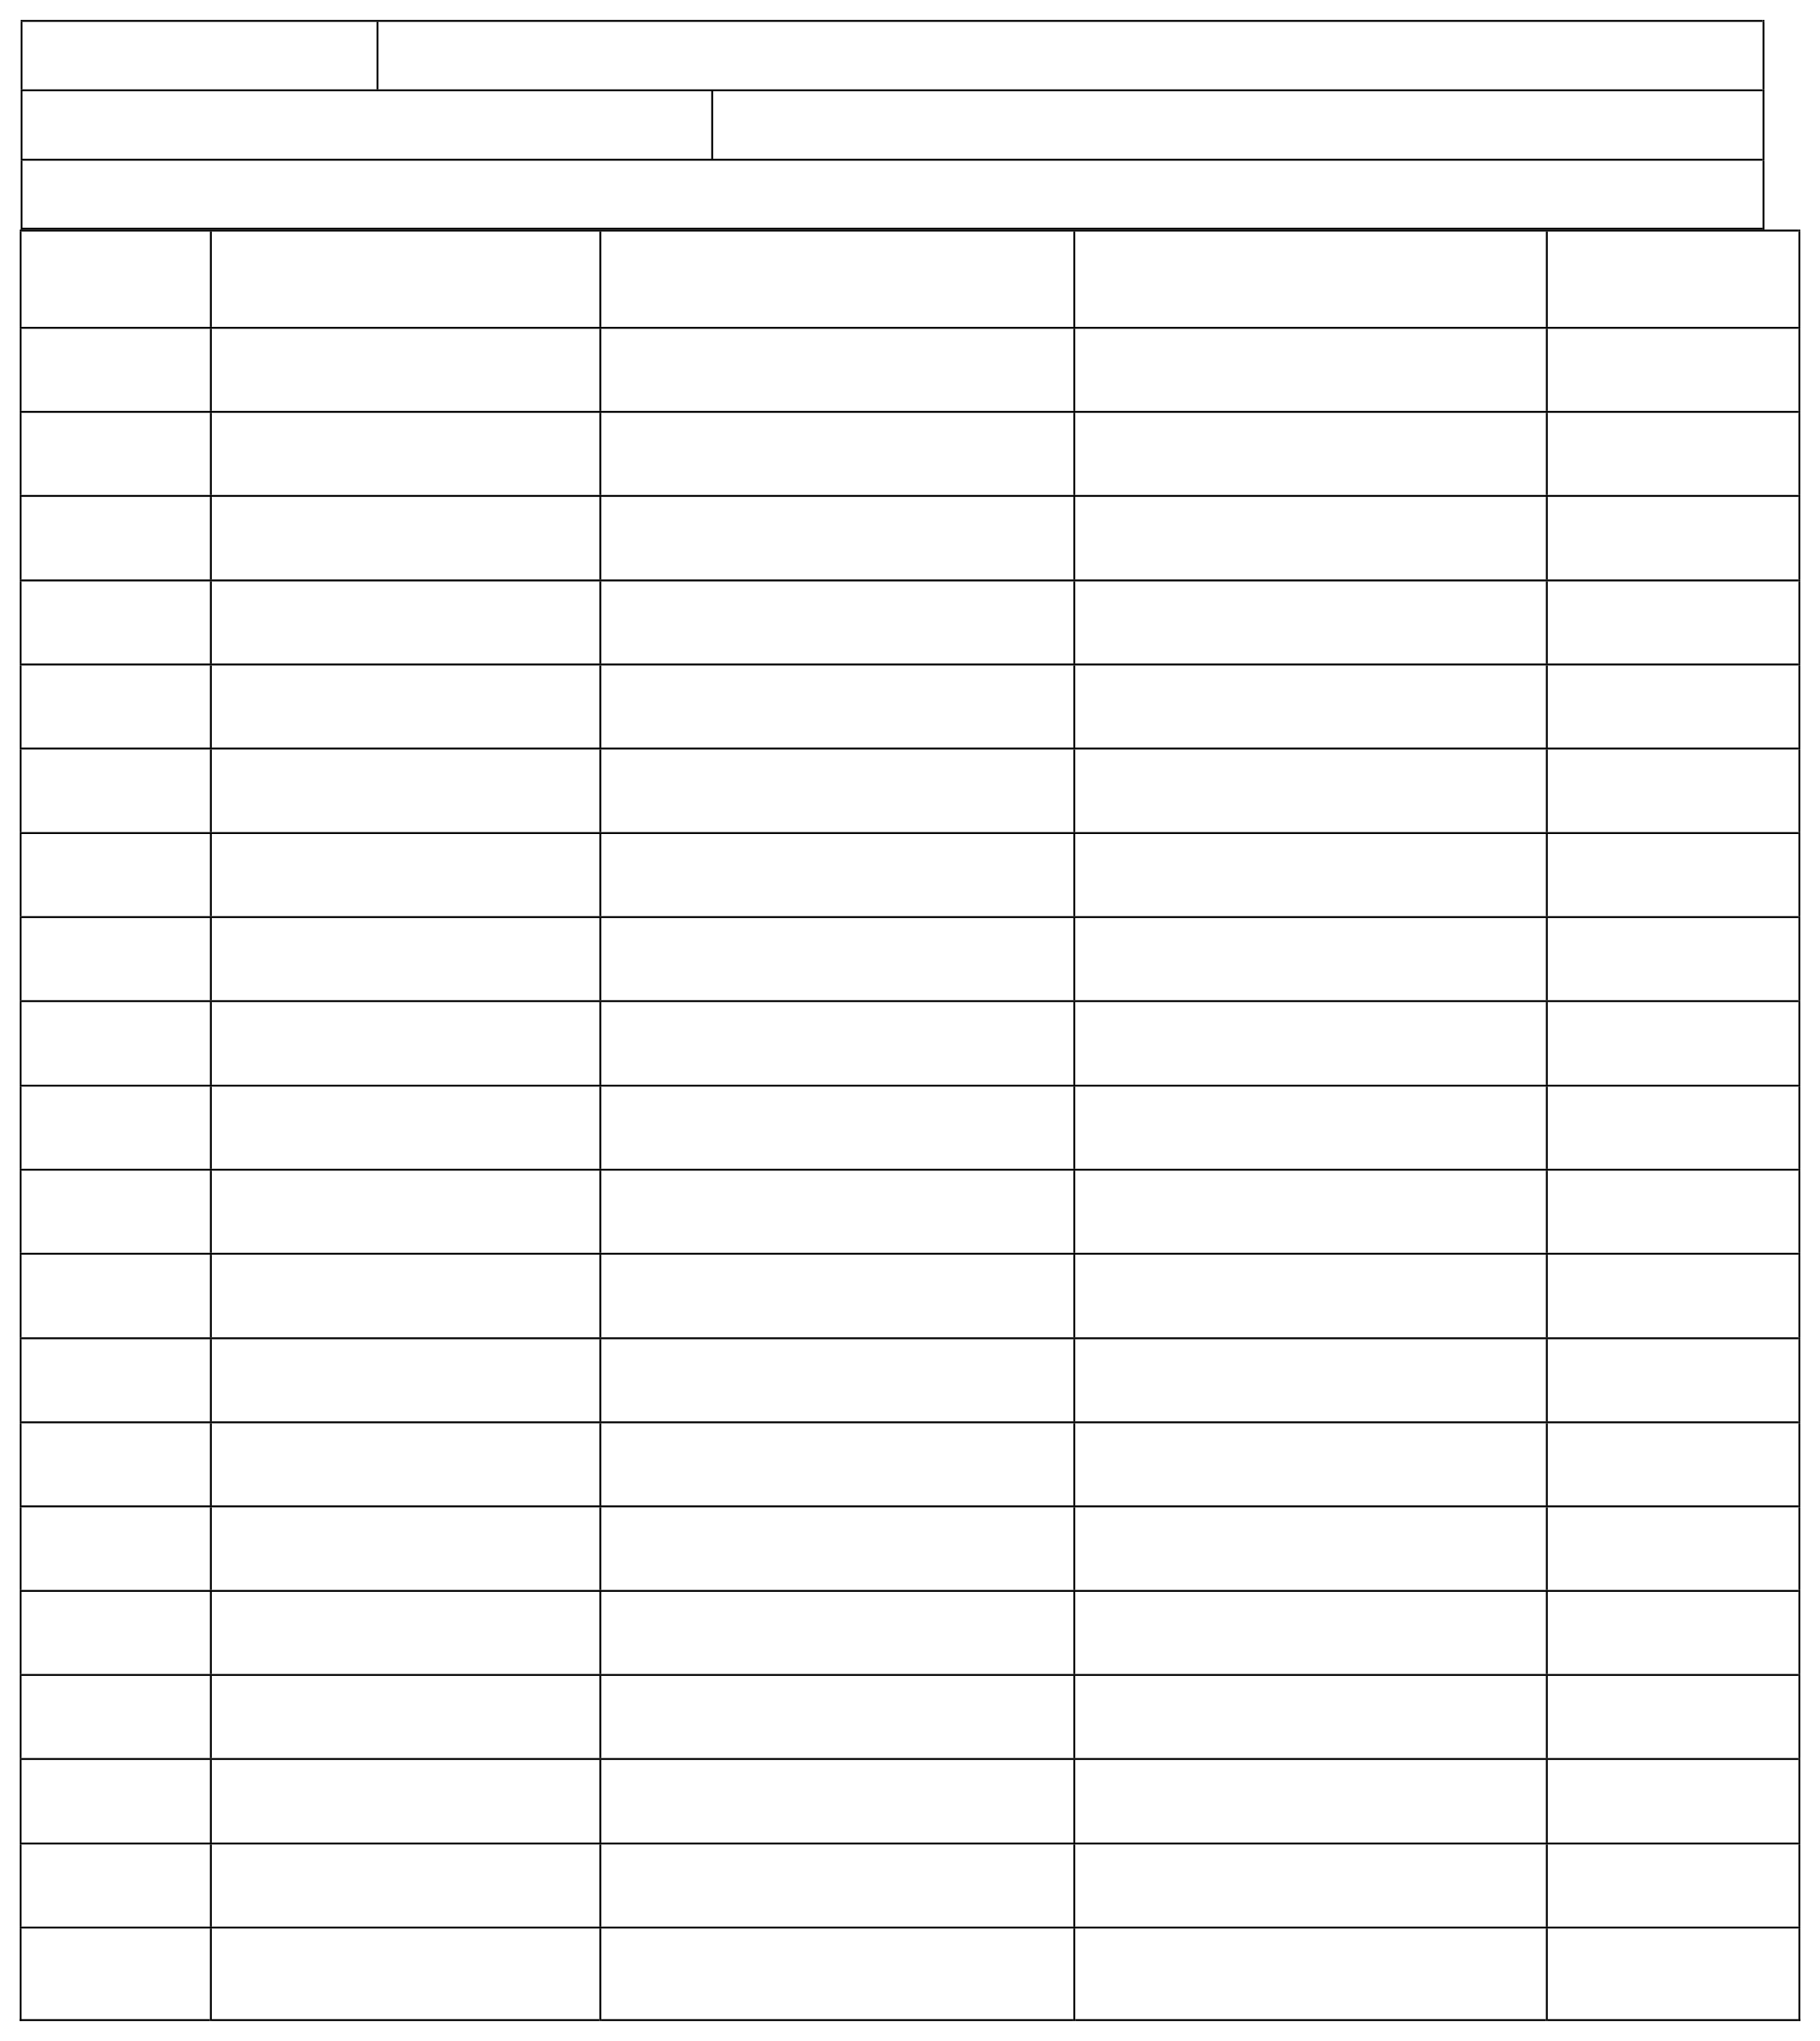Codiac Storm Lacrosse Codiac Cup 2025 – Player roster

Team Name: Division (U11, U13, U15 or U17):

Do not add more than 20 names to roster.

Athletes

(max 20)

1

2

3

4

5

6

7

8

9

10

11

12

13

14

15

16

17

18

Goalie Goalie

Jersey # First name Last name Birth year